"A 'D' check inspection of the wiring in the aft baggage compartment (R/H, lower area) found some burned wires," says this repair station technician. "These wires had shorted out—burning through their insulation. *(Noted strands include)* W740 R/H Fan N1 RPM Indicator and W748 R/H Turbine N2 Indicator.

"This *(area/wiring)* needs to be inspected thoroughly as *(failed wiring)* will cause indication problems in the cockpit and possibly a fire. The damaged wires were replaced."

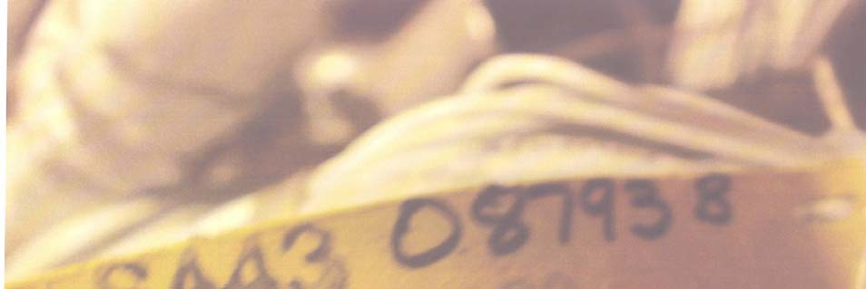

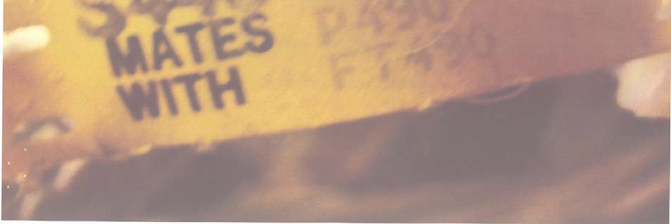

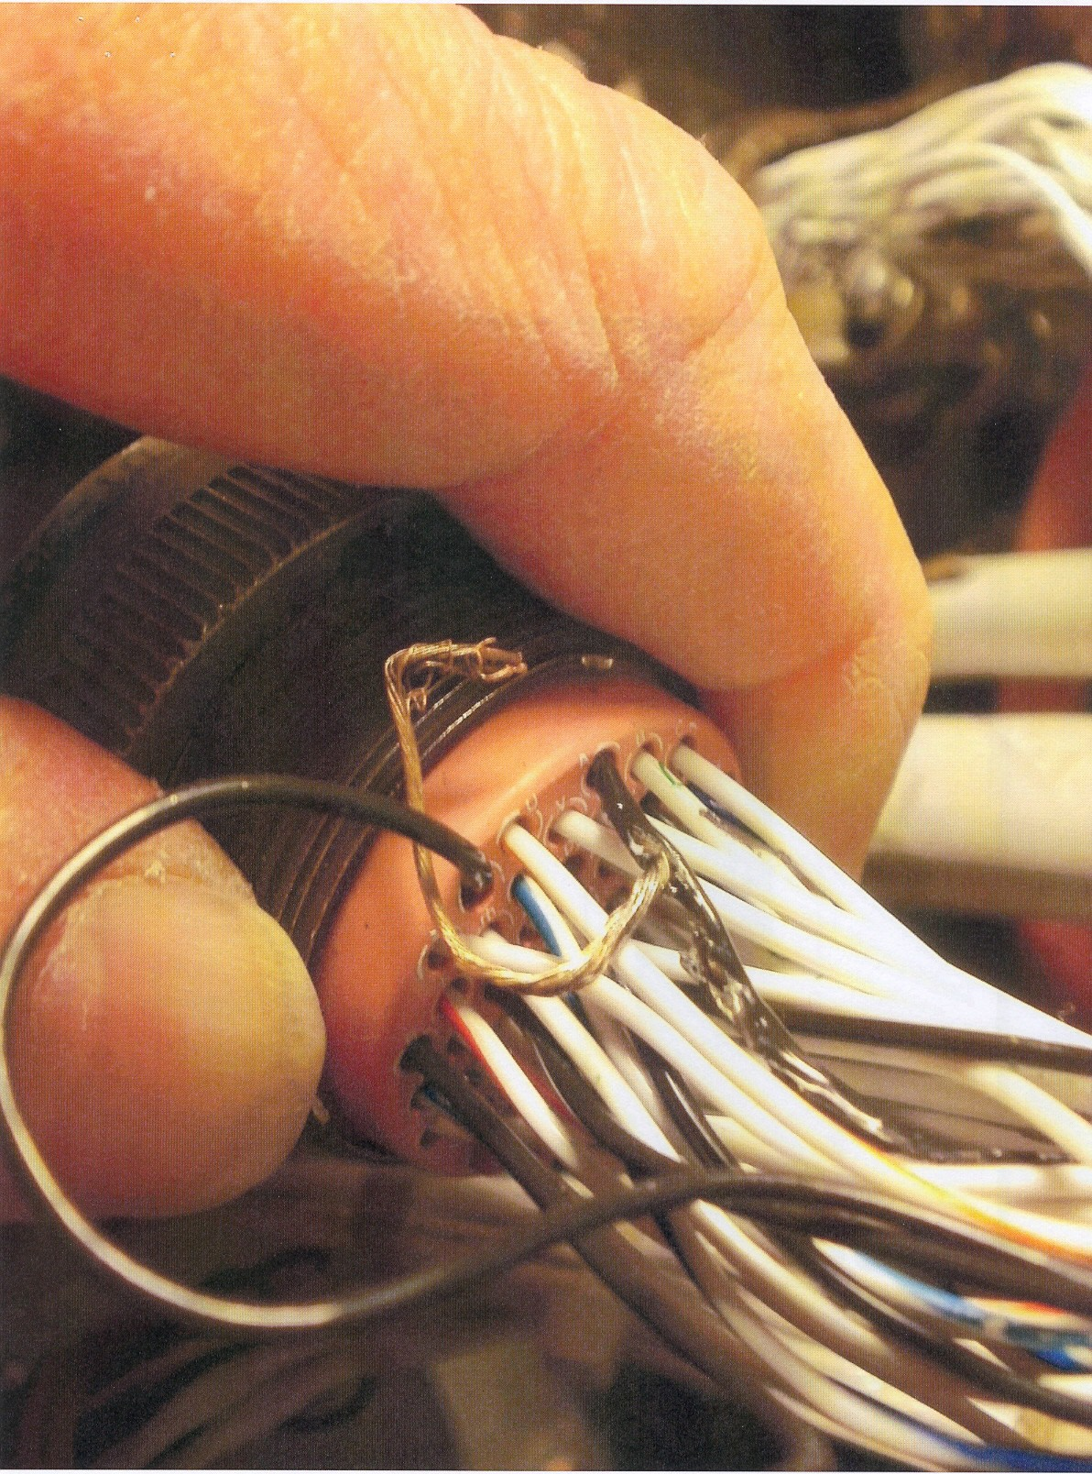

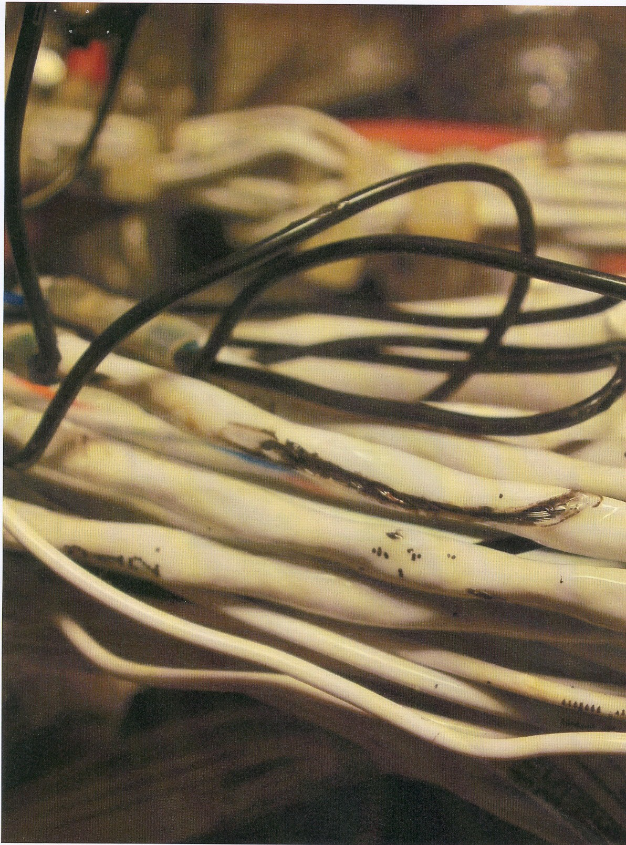

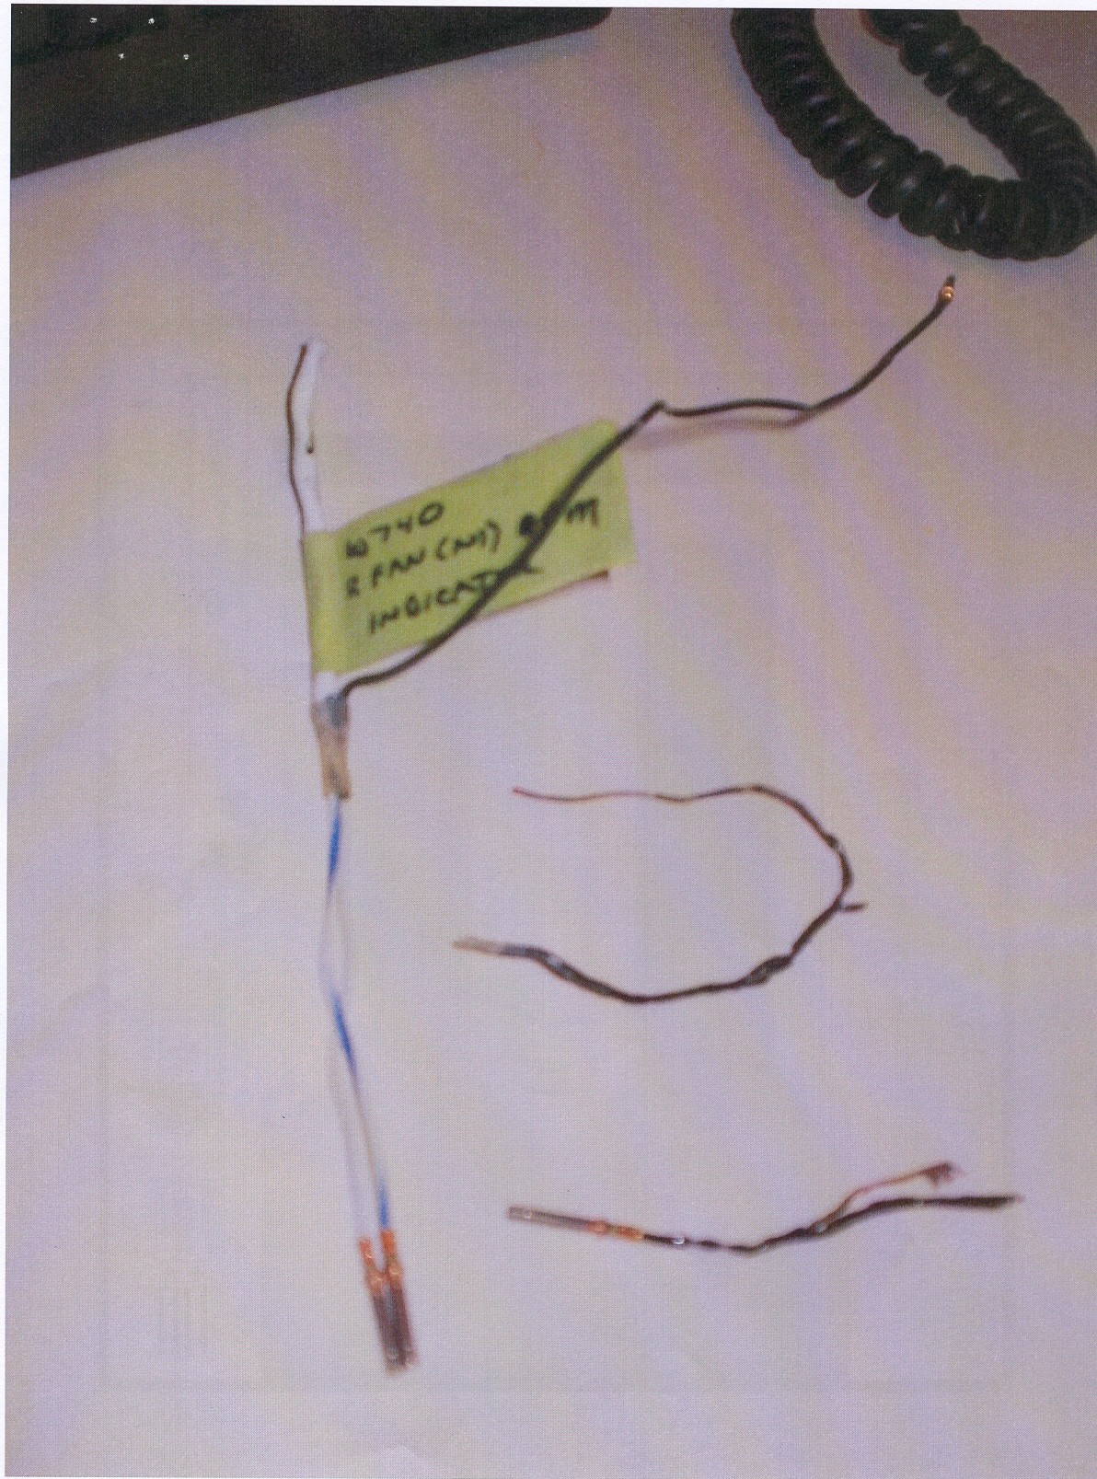

*(What caused the shorts? Chaffing? Poor connections? Impact damage? Now I have no idea "Who Done it"—Ed.)*

Part Total Time: (unknown)

Part Total Time: 980 Hours